Name: Sergio Gutierrez

bitbucket Repo: <https://bitbucket.org/SergioZGutierrez/homework1/src/master/>

Homework 1

Test Case 1:

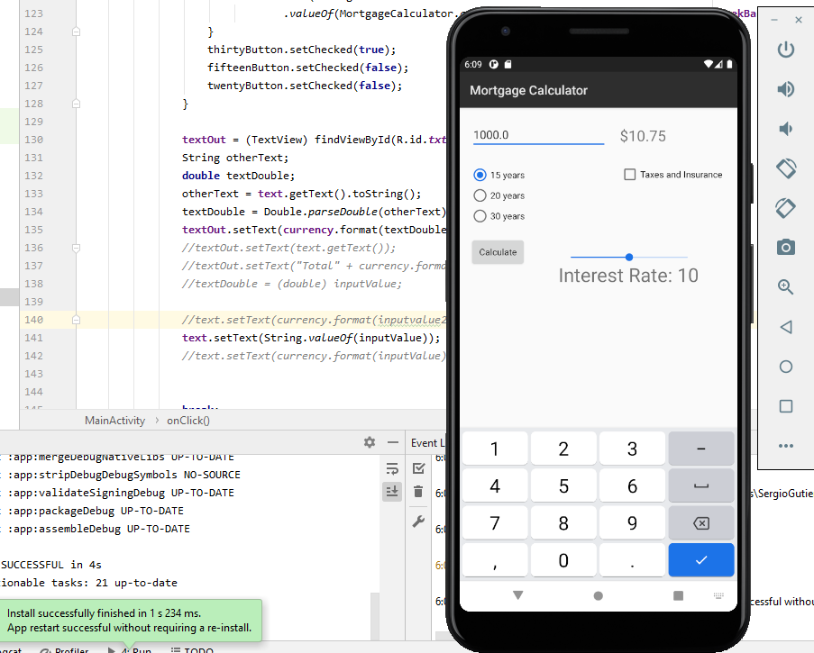

Test Case 2:

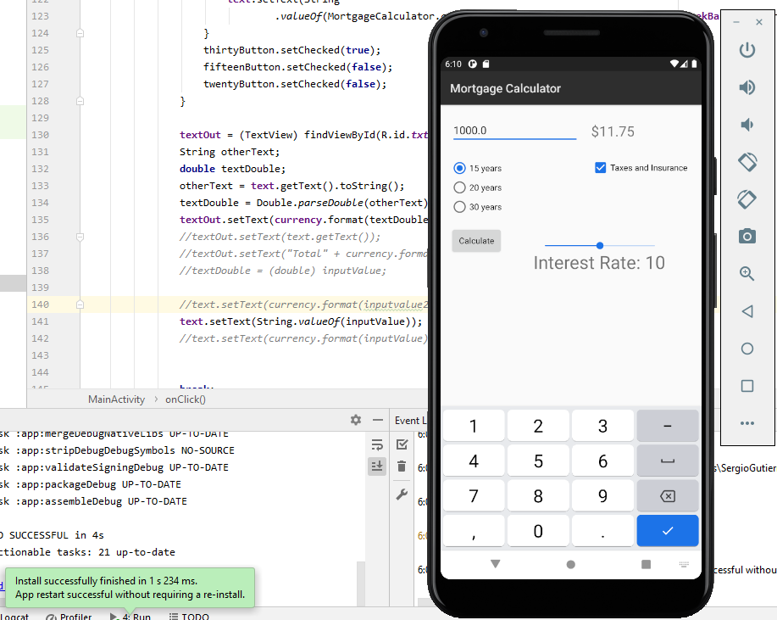

Test case 3:

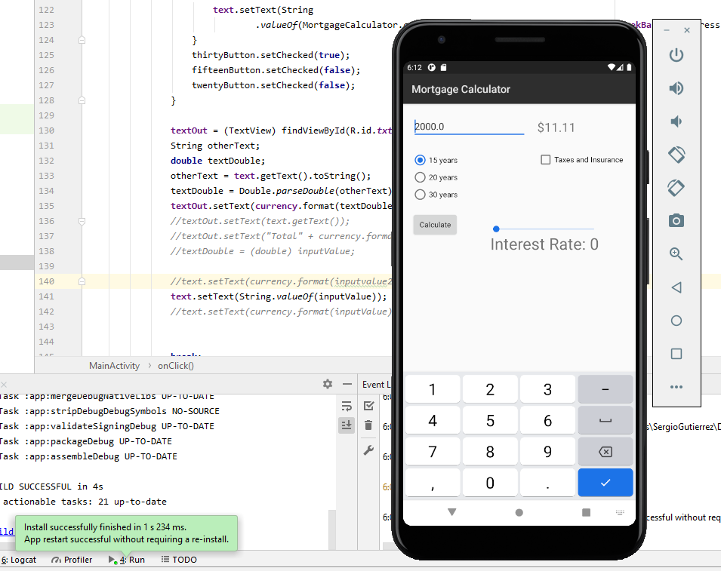

Test case 4:

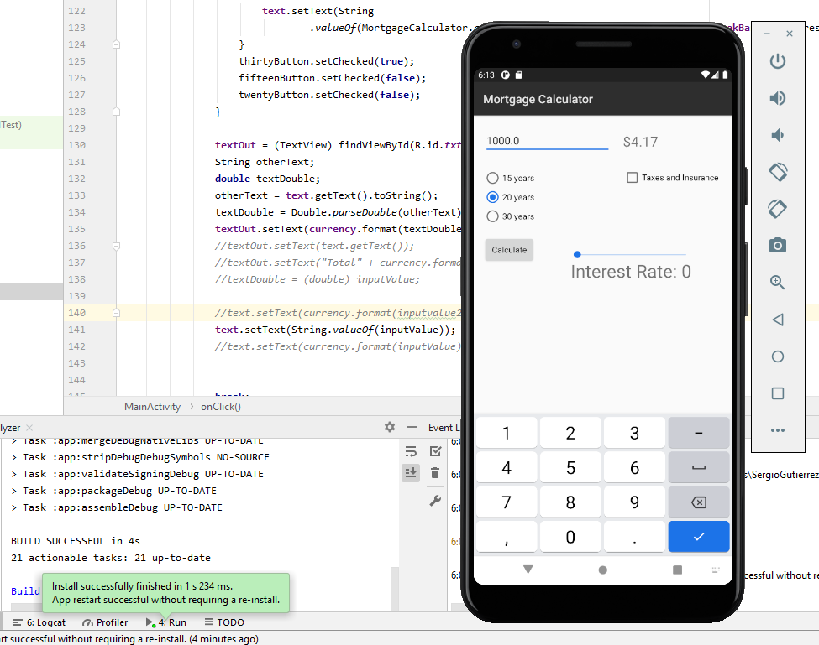

Test case 5:

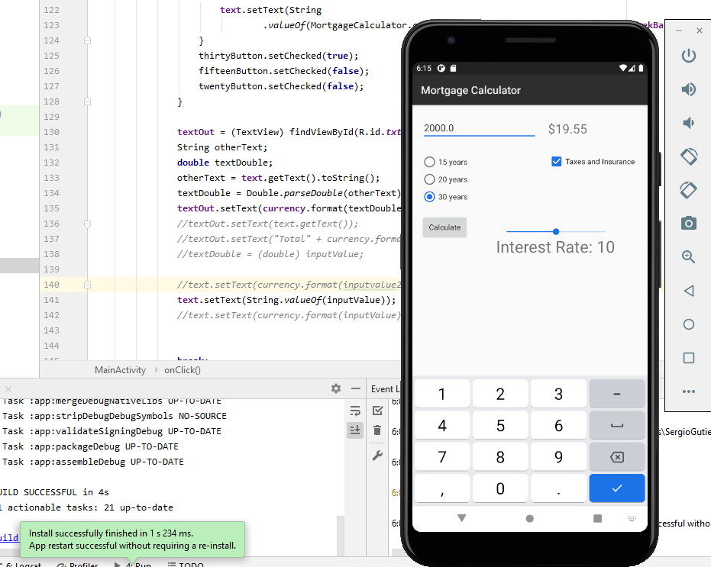

The exact pathway of where the .java files are located in my repository is:

<https://bitbucket.org/SergioZGutierrez/homework1/src/master/app/src/main/java/edu/sjsu/android/homework1/>